Amit Devichand Zambad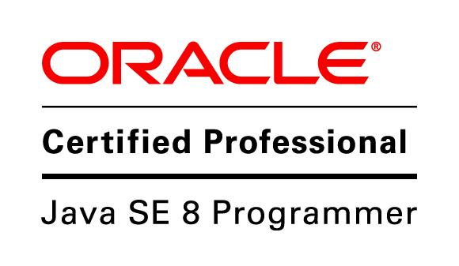

**Mississauga, ON | 437-967-5551 |** [**amitzambad@hotmail.com**](mailto:amitzambad@hotmail.com)

[**www.linkedin.com/in/amitzambad**](http://www.linkedin.com/in/amitzambad)

# Summary

I am an experienced software professional with almost 10 years of experience in developing server-side and UI applications. I work well with management to integrate functions, enhance systems, and improve processes. I am skilled in Java (Version 11 and higher), Spring Boot, and Hibernate. I have strong skills in system analysis and database management. I am known for my problem-solving skills, project management, and clear communication.

I use design patterns and unit testing frameworks to ensure high-quality code and effective communication within teams. I have experience in creating relational data models, developing REST APIs, and implementing message broker-based distributed architectures using Kafka. I am committed to maintaining high standards in software development and enjoy working in environments that value technical excellence, integrity, and continuous improvement.

# Skills

|  |  |
| --- | --- |
| * Java (1.8 and 17) * Spring Boot * RESTful Web Services * Microservices * IntelliJ / Eclipse | * Hibernate * SQL Server * AWS Cloud * Apache Kafka * Git |

# Licenses & Certifications

# OCAJP 1Z0-808 - Oracle

# OCPJP 1Z0-809 - Oracle

# Experience

**Technical Lead** Synechron Canada Inc (Client Citi Group) Jul 2023 - Present (1 year 7 months)

* Write high-quality, scalable, supportable, and extensible code for software applications.
* Review code quality and provide optimized solution for existing SQL queries
* Ensure seamless integration of the software stack with our existing CI pipeline, contributing to continuous improvements.
* Design, plan, and deliver high-quality software independently, maintaining excellence in execution.
* Embody the values of technical excellence, integrity, support, and compassion for individuals.
* Actively contribute to the ongoing improvement of processes and operations, ensuring the highest standards in software development.
* Develop and integrate Spring Boot, Microservices with Kafka Services, new Java upgrades (Java 17) into the existing infrastructure.
* Work effectively with globally distributed teams, understanding complex workflows and ensuring smooth collaboration.

**Technology Lead** Synechron India (Client Citi Group) Oct 2020 - Jul 2023 (2 years 10 months)

* Lead the analysis, estimation, and resolution of BAUs related to Brazil Trade Processing and confirmations, utilizing expertise in Java Development, Core Java, and Unix tools.
* Facilitated intercommunication between microservices using Kafka Services for seamless data exchange.
* Developed and integrated cutting-edge Java Microservices, including Java 17 and Spring Boot, ensuring compliance with regulatory requirements.
* Embraced test-driven development and continuous integration platforms, maintaining high code quality and fostering effective communication within the team.

**Sr. Software Engineer** Quess IT Staffing India. (Client Sears Holding) Dec 2019 - Aug 2020 (9 months)

* Managed and implemented effective pricing strategies and offers using Java and Spring Boot, ensuring optimized SQL scripts and enhancing competitive pricing structures.
* Oversaw the entire pricing model process, leveraging AWS to ensure alignment with business objectives and customer expectations.
* Demonstrated leadership and effective communication while working closely with various teams to implement seamless pricing strategies.

**Product Engineer** Intellect Design Arena Ltd India. Dec 2018 - Dec 2019 (1 year 1 month)

* Ensured smooth transaction flows and accurate documentation, integrating iGTB-Supply Chain Finance & Trade systems.
* Improved transaction processing efficiency by 15% through streamlined processes and automation.
* Enhanced system performance and compliance by developing and integrating Java EE servlets and Lambda functions.
* Developed and optimized SQL scripts to increase throughput and ensure smooth system operations.

**Software Engineer** e-Zest Solutions India. Jun 2015 - Aug 2018 (3 years 3 months)

* Developed an enterprise mobile application integrating Salesforce, Gmail, Exchange, and Dropbox, leveraging Restful Web Services.
* Implemented offline Salesforce opportunities sync and intelligent notifications (IQ Notifications) using Kafka, increasing user engagement by 10-15%.
* Integrated Java 8 with Spring Boot and an Authentication token system, strengthening security and maintaining compliance with authentication standards.

# Education

## Welingkar Institute of Management

### PGDM, Accounting and Finance

2016 - 2018

## Rajiv Gandhi College of Engineering & Research

### Bachelor's Degree, BE (I.T.)

2011 - 2014